|  |  |
| --- | --- |
| Isambard kingdom brunel engineer Black ...The Clifton Suspension Bridge - PILOT ... | Isambard Kingdom Brunel  Engineer |
| Alexander Graham Bell: 8 words that ... | Graham Bell  Inventor |
| FEMALE INVENTORS_Michelle (1).pdf | Maria Beasley  Inventor |
| 5 Eccentric Facts About Isaac Newton ... | Isaac Newton  Mathematician |
| George Washington Carver: The Patron ... | George Washington Carvers  **Scientist and Chemist** |

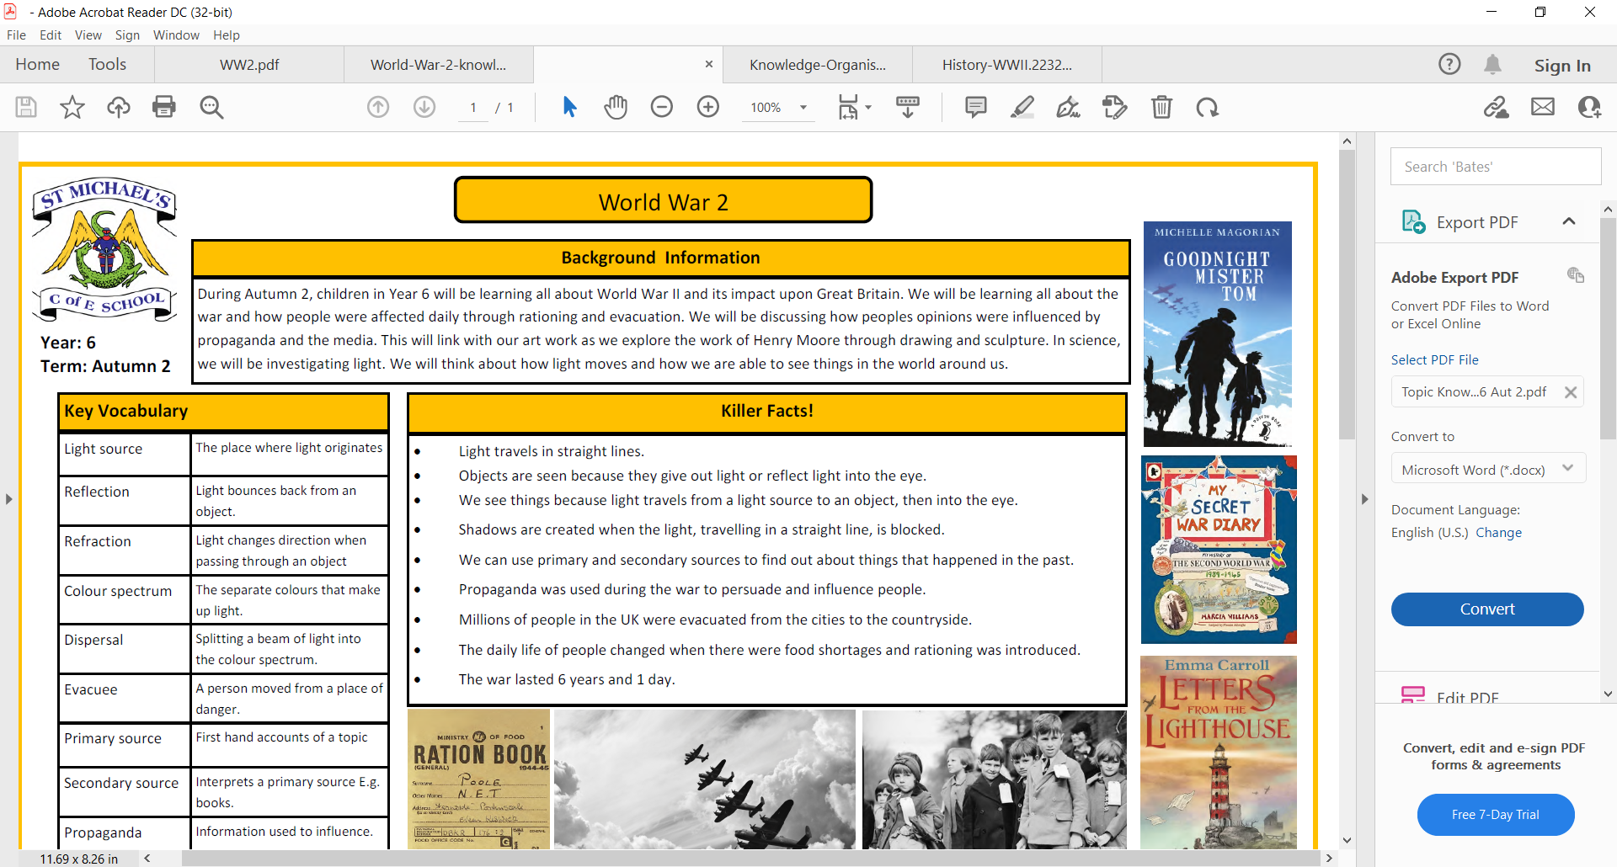

What would our lives be like without telephones or bridges?

Key People

STEM careers and Significant People

Autumn 2

We will be focusing on several STEM careers to focus on aspirations for future careers

|  |  |
| --- | --- |
| Engineer | a person who designs and builds things, machines, systems, or structures. |
| Invention | something that has never been made before. |
| Inventor | someone who has invented something or whose job is to invent things. |
| Mathematician | Somebody who uses maths to solve problems |
| Scientist | People who discover new things and research how things work. |
| Research | To study something to find out more information about it. |
| a **significant person** | Someone we remember due to their achievements or way of life. |

|  |  |
| --- | --- |
| Previous learning | National Curriculum |
| Ask questions  Make observations | Asking simple questions and recognising that they can be answered in different ways  Observing closely, using simple equipment  Performing simple tests |