Animals including Humans

Protection and Movement
Skeletons

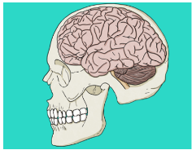
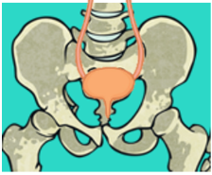
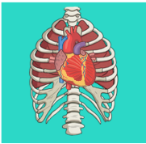
All skeletons can be classified into two groups, invertebrates and vertebrates.
The skeleton protects different organs in the body. For example:
The skull protects the brain.
The rib cage protects the heart.
The pelvis protects the bladder.
The human skeleton is important for movement, protection and support.

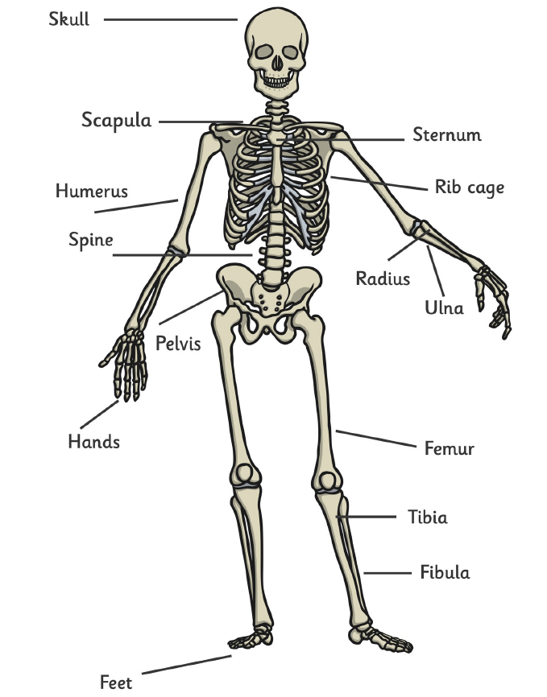
Vertebrates have a backbone inside the body.
Invertebrates do not have a backbone.

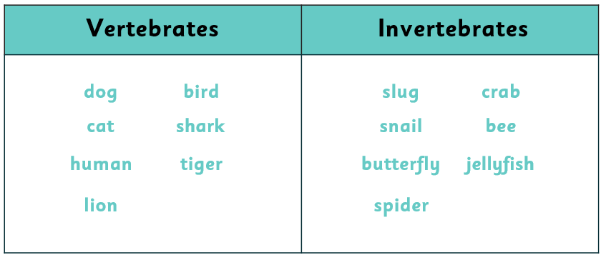

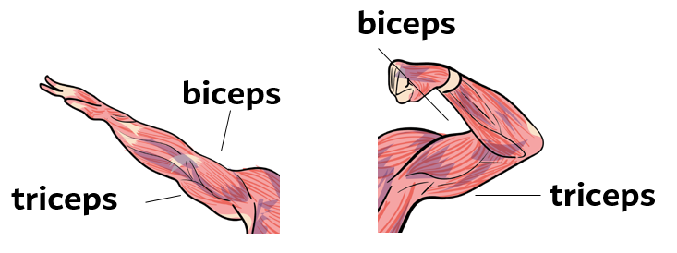
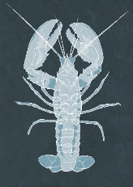
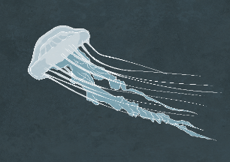
The muscles are attached to the bones and make the skeleton move.
When the arm straightens, the bicep relaxes the triceps contract. When the arm is bent, the biceps contract and the triceps relax.
Animal skeletons can be grouped into 3 different groups endoskeleton, exoskeleton and hydro skeleton.
offspring | A person or animals child.
survival | To live or exist.
nutrition | Having or providing food necessary for health and growth.
growth | The process of increasing in size.
hygiene | Keeping clean to stay healthy.
exercise | Activities that require physical effort.
carbohydrates | A type of food that is a source of energy, for example pasta.
protein | A type of food that helps to build and repair muscles.
fats | A type of nutrient that the body needs but not too much of.
Vitamins and minerals | This is found in foods and helps the body to work properly.
muscular system | All of our muscles working together.
muscle | How we move and live.
contract | This pulls the bones it is connected to closer together.
relax | A muscle returns to resting position.
bones | These make up the skeleton.
skeleton | Provide support for our bodies and help form our shape.
skeletal system | All the bones in the human body together.
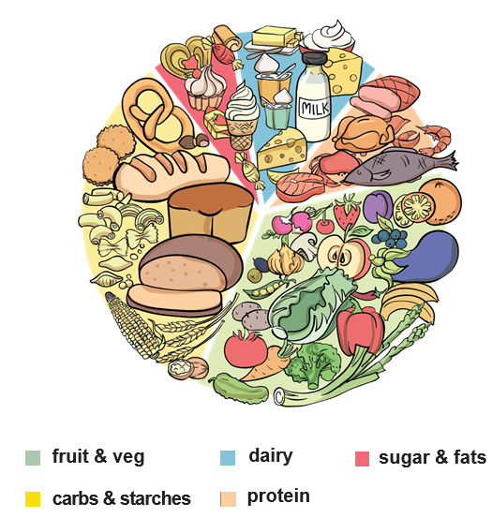
Images from Grammarsaurus
Humans need to eat a healthy balanced diet. The Eat Well Plate is a guide to show us how much of each type of food we should eat.
Nutrition
Key Vocabulary

