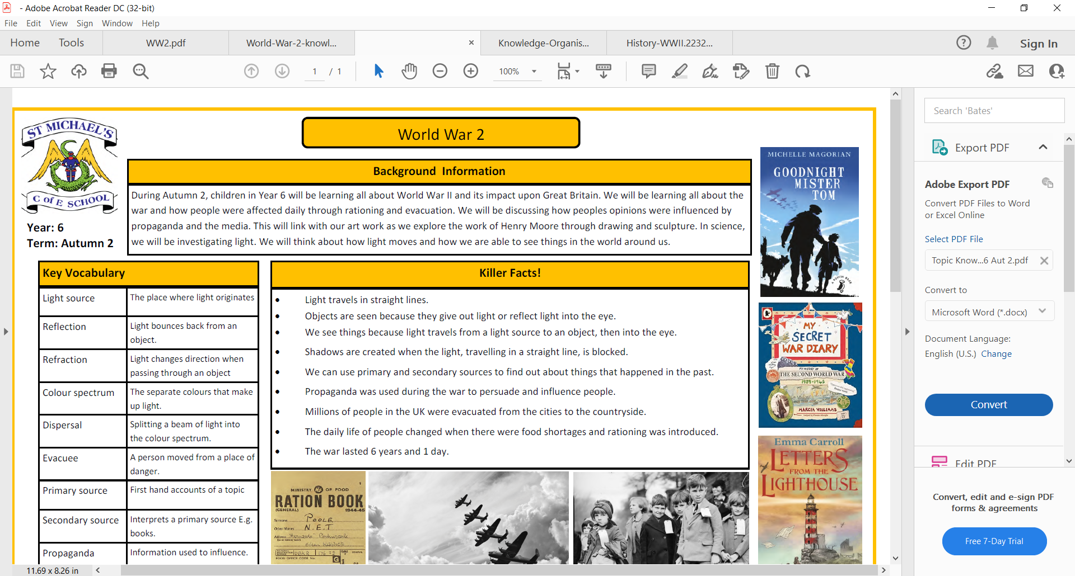

Key concepts:

Historical figures, Lifestyles, Progress and Change.

**Enquiry question**: What happened on November 5th?

**The Gunpowder Plot**

Guy Fawkes

|  |  |  |
| --- | --- | --- |
| Timeline | | |
| May 1604 | 26th October 1605 | 5th November 1605 |
| The group begin to plotGuy Fawkes and the Gunpowder Plot 1605 | Lord Monteagle receives a letter warning him not go to the Houses of Parliament.  William Parker Lord Monteagle ... | The Plot failed. Guy Fawkes is found in the cellar with 36 barrels of gunpowder by one of the King’s guards. Guy Fawkes, caught in the act of ... |

King James I was the King of England he was a protestant.

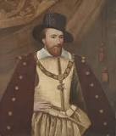

The plot was to kill the King and blow up the houses of Parliament.

They planned the plot because they were Catholic and felt they were being treated unfairly.

The plot failed.

We commemorate this every year on 5th November by burning bonfires and having firework displays.



Vocabulary

How has the Gunpowder plot effected our lives today?

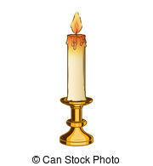Have fireworks always existed?

|  |  |
| --- | --- |
| Gunpowder | An explosive powder that was used in guns. |
| Barrel | A container made of wood to store food and wine. |
| A large building on a river with Palace of Westminster in the background  Description automatically generatedHouses of Parliament | The building in London where the government works. |
| Monarch | A King or Queen |
| Plot | A secret plan to do something that is illegal or wrong. |