Rocks

Prior Year 2 learning
Year 3 Learning
In Year 2, we learnt:
- identify and compare the suitability of a variety of everyday materials, including wood, metal, plastic, glass, brick, rock, paper and cardboard for particular uses.
- find out how the shapes of solid objects made from some materials can be changed by squashing, bending, twisting and stretching.
Soils
Fossils
In Year 3, we will learn:
- compare and group together different kinds of rocks on the basis of their appearance and simple physical properties.
- describe in simple terms how fossils are formed when things that have lived are trapped within rock.
- recognise that soils are made from rocks and organic matter.

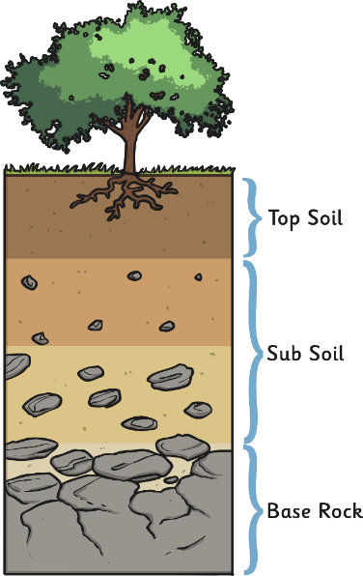
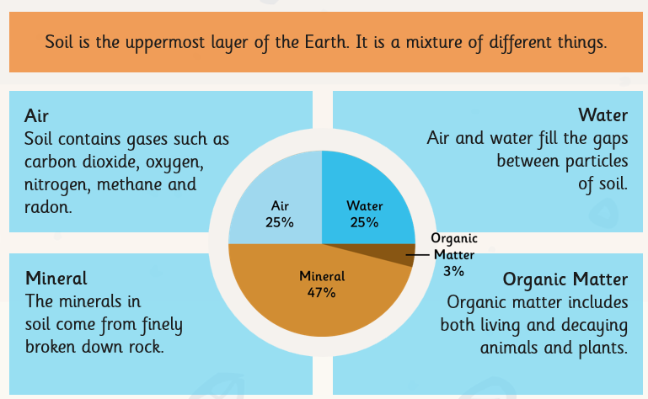

A fossil is the remains or traces of prehistoric life. Fossils are the preserved remains of animals and plants. Fossils are formed when animal or plant remains are buried in sediment. Impressions of animal activities, such as footprints, can also become fossils.

Types of Rock
Key Vocabulary
rock | This is solid and it forms part of the earth’s crust.
stone | A solid matter of rock.
boulder | A large rock.
grain | A very small piece of rock.
crystal | A piece of natural rock that often sparkles.
igneous | A type of rock that is formed from magma or lava.
metamorphic | A rock that has undergone change.
sedimentary | A rock that has been formed by lots of layers of sediment.
classify | To arrange into groups according to characteristics.
fossils | The remains or impression of a prehistoric plant or animal.
permeable | Allowing liquid or gases to pass through.
impermeable | Not allowing liquid or gases to pass through.
porous | An object that has minute spaces or holes through which liquid or gas may pass.
soil | A black, or dark brown, material typically consisting of a mixture of organic remains, clay, and rock particles.
organic matter | Materials that have come from recently living organisms.

There are 3 main types of rock
Igneous | Sedimentary | Metamorphic
Igneous rock is formed when molten magma, from a volcano, cools down. | These rocks form under the sea, over millions of years. This happens when tiny pieces of bones and shells from animals and other pieces of tiny rock are pressed into layers. | Metamorphic rocks are formed when other rocks are affected by great temperature or pressure. This happens under the surface of the earth.
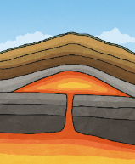  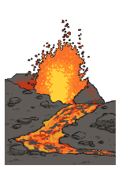 | 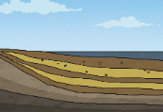  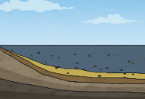 | 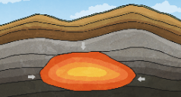  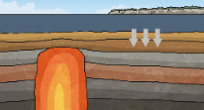

Images from Grammarsaurus

