Poles Apart
Key concepts:
Space
Place

Arctic and Antarctic Circle
e
Antarctic
Arctic
The Arctic is southmost point on earth. In the Antarctic circle there are animals such as penguins, whales, seals and the albatross.

The Arctic is northmost point on earth. In the Arctic circle there are animals such as Arctic fox, polar bear, snowy owl, arctic hare and arctic wolf.

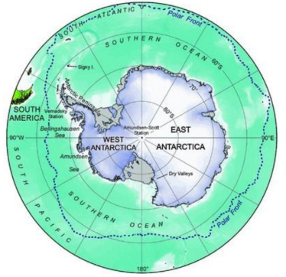
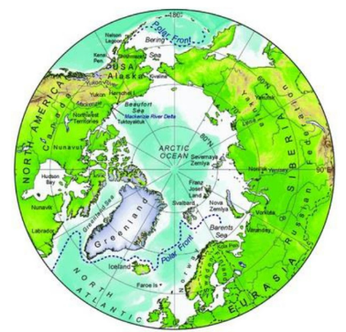

Countries in the Arctic circle.
Compass and Compass points
There are 8 countries in the Arctic circle. These are:  Canada  Greenland  Iceland  Norway  Sweden  Finland  Russia  The United States | There are no countries in Antarctica but 7 nations claim different parts of it. These are:  New Zealand  Australia  France  Norway  the United Kingdom  Chile  Argentina
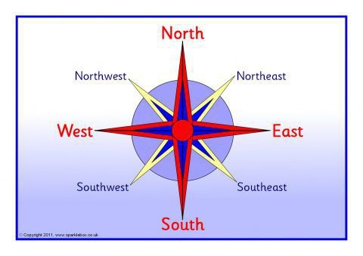

Compass | A tool for finding direction.
Compass Points | The directions on a compass.
Arctic | The region around the North Pole.
Antarctic | The region around the South Pole.
Map | A representation of an area of land and sea.
Atlas | A book of maps and charts.
North Pole | The northmost point on earth.
South Pole | The southmost point on earth.
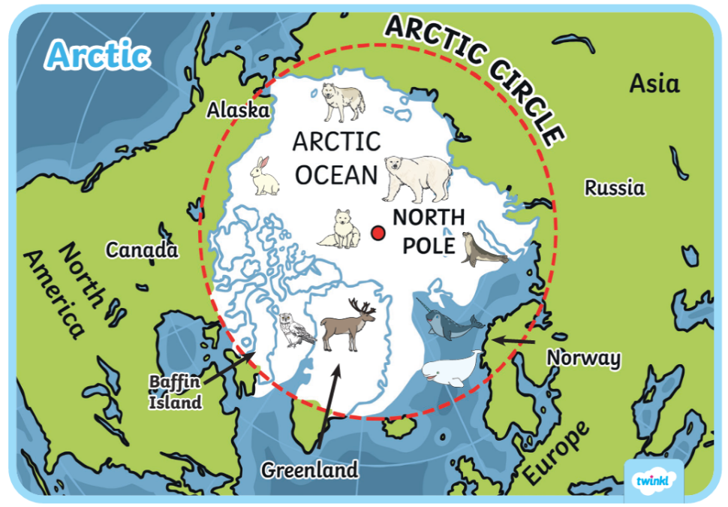
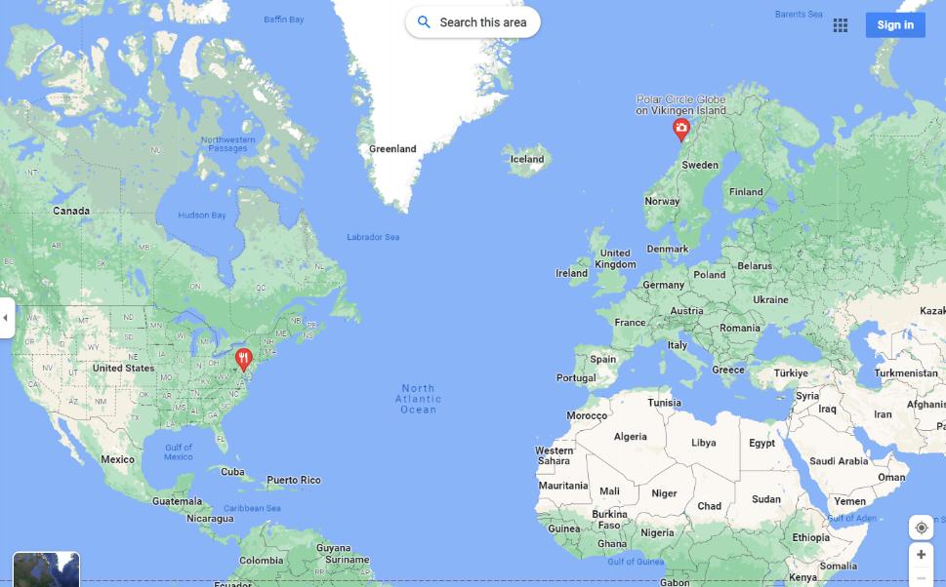
What can we do in our everyday lives to help the planet?
Map of the Antarctic
Map of the Arctic
Key Vocabulary

