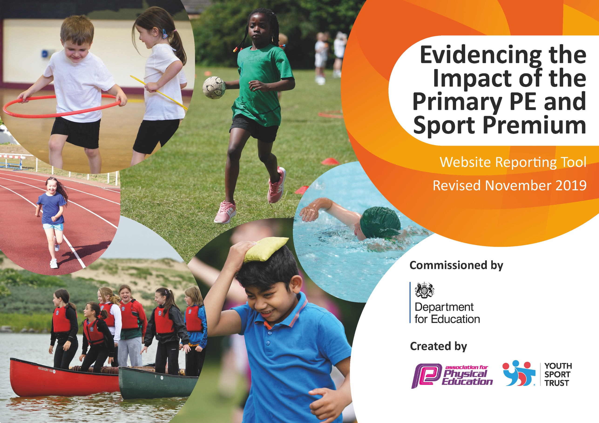
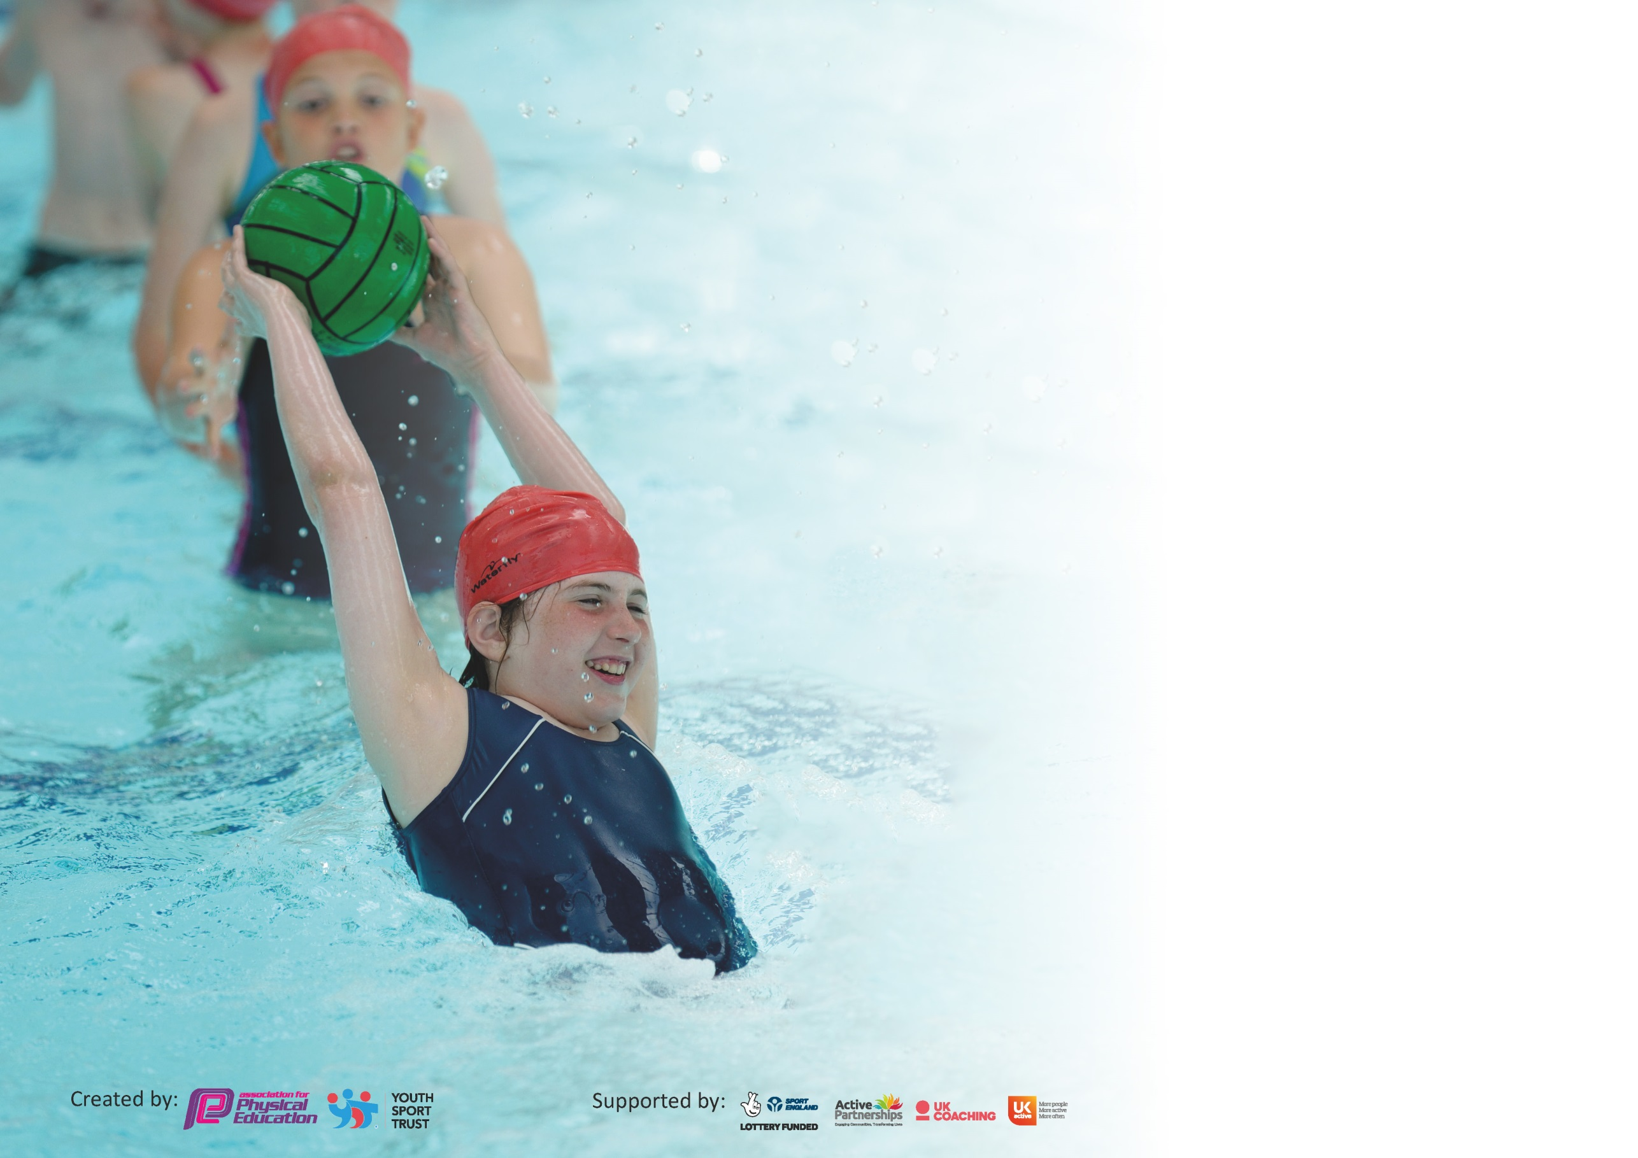

It is important that your grant is used effectively and based on school need. The Education Inspection Framework (Ofsted 2019 p64) makes clear there will be a focus on ‘whether leaders and those responsible for governors all understand their respective roles and perform these in a way that enhances the effectiveness of the school’.

Under the Quality of Education criteria (p41) inspectors consider the extent to which schools can articulate their curriculum (INTENT), construct their curriculum (IMPLEMENTATION) and demonstrate the outcomes which result (IMPACT).

To assist schools with common transferable language this template has been developed to utilise the same three headings which should make your plans easily transferable between working documents.

Schools must use the funding to make additional and sustainable improvements to the quality of Physical Education, School Sport and Physical Activity (PESSPA) they offer. This means that you should
use the Primary PE and Sport Premium to:

- Develop or add to the PESSPA activities that your school already offer
- Build capacity and capability within the school to ensure that improvements made now will benefit pupils joining the school in future years

Please visit gov.uk for the revised DfE guidance including the 5 key indicators across which schools should demonstrate an improvement. This document will help you to review your provision and to report your spend. DfE encourages schools to use this template as an effective way of meeting the reporting requirements of the Primary PE and Sport Premium.

We recommend you start by reflecting on the impact of current provision and reviewing the previous spend.

Schools are required to publish details of how they spend this funding as well as on the impact it has on pupils’ PE and sport participation and attainment by the end of the summer term or by 31st July 2020 at the latest.

We recommend regularly updating the table and publishing it on your website throughout the year. This evidences your ongoing self-evaluation of how you are using the funding to secure maximum, sustainable impact. Final copy must be posted on your website by the end of the academic year and no later than the 31st July 2020. To see an example of how to complete the table please click HERE.

Support for review and reflection - considering the 5 key indicators from DfE, what development needs are a priority for your setting and your pupils now and why? Use the space below to reflect on previous spend and key achievements and areas for development.

Meeting national curriculum requirements for swimming and water safety.
What percentage of your current Year 6 cohort swim competently, confidently and proficiently over a distance of at least 25 metres?  N.B. Even though your pupils may swim in another year please report on their attainment on leaving  primary school at the end of the summer term 2020. | 82%
What percentage of your current Year 6 cohort use a range of strokes effectively [for example, front crawl, backstroke and breaststroke]? | 76%
What percentage of your current Year 6 cohort perform safe self-rescue in different water-based situations? | 72%
Schools can choose to use the Primary PE and Sport Premium to provide additional provision for swimming but this must be for activity over and above the national curriculum requirements. Have you used it in this way? | Yes/No

Action Plan and Budget Tracking
Capture your intended annual spend against the 5 key indicators. Clarify the success criteria and evidence of impact that you intend to measure to evaluate for pupils today and for the future.

Academic Year: 2019/20 | Total fund allocated: £19440.00  £8000 carried to 2021 | Date Updated: July 2020
Key indicator 1: The engagement of all pupils in regular physical activity – Chief Medical Officer guidelines recommend that primary school pupils undertake at least 30 minutes of physical activity a day in school |  |  |  | Percentage of total allocation:
 |  |  |  | %
Intent | Implementation |  | Impact
Your school focus should be clear what you want the pupils to know and be able to do and about  what they need to learn and to  consolidate through practice: | Make sure your actions to achieve are linked to your intentions: | Funding allocated: | Evidence of impact: what do pupils now know and what can they now do? What has changed?: | Sustainability and suggested next steps:
Early Bird Breakfast Club and Dragons After School Club continued in the school.  Wrap around care now offered for children after school finishes.  Continue Wake and Shake each morning.  All children using the 5 a day Wake and Shake sessions at the start of the day before lessons begin. Just Dance has been included to this to engage with the older children.  Children aware of the importance of physical activity on their minds and body.  Introduce more activities at lunchtime  The new system will provide the children with a range of activities to try to ensure that they are active and engaged throughout the week.  Children aware of the importance of physical activity on their minds and body.  Increase the use of the Bike Track during school time and after school.  This will increase physical activity for the children in the school (Daily Mile) and enable children to bring in bikes from home to improve their riding abilities. Make links to Bikeability for Year 5 and 6  Continue Healthy week  All children participate and outside agencies invited in to talk about monitoring healthy lifestyles. | Continue to monitor the provision on offer to ensure that the children are fully engaged and have access to physical activity.  Purchase additional sporting/physical activity equipment to support this.  Ensure new members of staff have log ins.  Staff to rotate the routines to sustain fun and enjoyment.  Establish new Play-leaders, craze of the week, zones and House matches to increase physical activity across the school for pupils to engage in.  Identify lunchtime staff to undertake/oversee activities, Provide training where needed. - Purchase equipment to aid this delivery. - Select & train Year 5 pupils to become play leaders and purchase equipment especially for lunchtime activities.  Continue the daily mile. The children to walk/Jog/Run during a slot in the school day. The track is now been established and is all weather. The track is also currently being used at lunchtimes as a bike track and after school as a club opportunity.  Ensure that staff timetable a variety of different activities that are healthy and link to their curriculum.  Include in the newsletter to inform parents.  Set up a walking bus.  Establish the House Games competition. | £600  £598.85  £252  £500  £279.84  £500 - £1000  No cost | Children having access to sporting opportunities before and after school. Increasing physical activity. More children are active during the session and were involved in purchasing the equipment to ensure that they would engage with it.  Left/right brain workout in the morning before work begins. Improvement in concentration.  More pupils are physically active during the school day. - Better attitudes to learning in the afternoon as concentration is improved. Increased awareness of a healthy lifestyle.  Increase in participation of sporting events/enrichment clubs.  Children to be involved with improving their house results.  All children throughout the school having access to the bike track at different times during the week.  Children more confident when using their bikes on the track. This will be evident during Bikeability training and at residential camps e.g. IOS  Children have an awareness of having a healthy, balanced lifestyle. Understand the importance of daily physical activity on maintaining their own health and well-being. | This will need to be looked at in the Autumn term to ensure that it is sustainable.  Encourage the children to create their own routines and to begin to lead the sessions. Year 5 to demonstrate routines at the Summer Fayre.  Continue to update equipment where needed.  School Councillors to ask their class what activities they would like to see at lunchtime.  Site supervisor to ensure the track remains safe all year.  Year 5 to have Bikeability training as well as Year 6.  Bikeability did not happen in the Summer due to school closure Covid-19  Ongoing focus timetabled for summer term each year.  Healthy Week did not happen in the Summer due to school closure Covid-19
Key indicator 2: The profile of PESSPA being raised across the school as a tool for whole school improvement |  |  |  | Percentage of total allocation:
 |  |  |  | %
Intent | Implementation |  | Impact
Your school focus should be clear what you want the pupils to know and be able to do and about  what they need to learn and to  consolidate through practice: | Make sure your actions to achieve are linked to your intentions: | Funding allocated: | Evidence of impact: what do pupils now know and what can they now do? What has changed?: | Sustainability and suggested next steps:
To improve on the SPORTSMARK awards from this year.  Improving the PE provision in school.  Children aware of the PE and sporting opportunities on offer in school and are signposted to clubs outside of school.  Deliver CPD to staff that identified areas of development in the staff audit.  Gymnastics in particular.  Purchase new PE resources  There needs to be a top up of resources in KS2 and KS1 need a complete update of resources. | Keep criteria and ref throughout the year. Encourage and promote attendance at events.  Swallows came into school in the Autumn term and provided quality teaching for the children and CPD to staff in the infants. We were working in Year 4 when interrupted by the school closure.  Audit equipment and place an order before the end of the Summer Term. | N/A  £3000  £960  £2000  £849.94 | Increase in participation, quality of lessons and the provision of PE and School Sport in school.  Links have been established with the local gym club to provide gymnastics training to the staff to ensure that they are confident in delivering gymnastic sessions.  School achieved 1st place in the KS1 gymnastics comp  Children will be active learners during lessons and teachers will be able to deliver lessons with the equipment needed. | PE lead to apply when window opens in the summer term. Time with relevant staff to collate details  Applications were cancelled in the Summer due to school closure Covid-19  Staff will be able to share the CPD with new members of staff.  This will need to be restarted next year to ensure that all staff have the CPD as some Year groups missed out due to the school closure Covid -19  Audits will take place regularly to ensure that staff have the resources needed to deliver their lessons. Train up PE monitors in the Autumn term for the junior crate and infant PE cupboard.  Will need to complete an order in Autumn term as there wasn’t one placed in Spring or Smmer

Key indicator 3: Increased confidence, knowledge and skills of all staff in teaching PE and sport |  |  |  | Percentage of total allocation:
 |  |  |  | %
Intent | Implementation |  | Impact
Your school focus should be clear | Make sure your actions to | Funding | Evidence of impact: what do | Sustainability and suggested
what you want the pupils to know | achieve are linked to your | allocated: | pupils now know and what | next steps:
and be able to do and about | intentions: |  | can they now do? What has
what they need to learn and to |  |  | changed?:
consolidate through practice:
Continue using the ARENA SOW  New PE curriculum purchased ARENA PE schemes of work. All staff trained on how to deliver the sessions and how to begin to assess.  Continue using Swimming SOW  Staff continuing to access schemes of work for swimming focusing on strokes, water safety and lifesaving skills.  PE Monitoring  In the academic year 2020-2021 the PE coordinators will be released to monitor the teaching and learning of PE across the school to ensure it is engaging for the children. They will also need to address the loss of physical activity that some will have had due to lockdown. | Add to school monitoring cycle  Continue to track the use of the schemes of work and ensure information has been passed to new teachers during transition.  Add to school monitoring cycle | N/A  N/A  Subject release time | Staff confident with the teaching of PE and delivering high quality lessons. Children accessing a fun programme of learning through ARENA PE where they develop agility, balance and co-ordination, healthy competition and cooperative learning.  Staff confident in delivering high quality swimming sessions ensuring that the school works towards the goal of all children able to swim 25 metres by the end of KS2.  Coordinators will see lessons with high quality PE and children will be engaged in the lessons. They will be aware of their learning outcomes and how to improve different skills. | Monitoring of the teaching of PE sessions.  Ensure all new staff are trained.  Photocopying plans each year.  Need to continue in the Spring term due to school closure and the Recovery Curriculum.  Swimming lessons for the year adapted to ensure that children swim from Y 1-6. In the summer the Year 6 children will swim with key children identified to ensure they meet the 25m expectation.  Continue to pupil conference to ensure that pupil’s needs are being met. Begin to look at specific groups in line with school’s monitoring such as FSM and pupil premium.  Add to cycle of monitoring.  Lockdown effects on children’s health and fitness.
Key indicator 4: Broader experience of a range of sports and activities offered to all pupils |  |  |  | Percentage of total allocation:
 |  |  |  | %
Intent | Implementation |  | Impact
Your school focus should be clear | Make sure your actions to | Funding | Evidence of impact: what do | Sustainability and suggested
what you want the pupils to know | achieve are linked to your | allocated: | pupils now know and what | next steps:
and be able to do and about | intentions: |  | can they now do? What has
what they need to learn and to |  |  | changed?:
consolidate through practice:
Additional achievements:  Curriculum and clubs are available for everyone.  Continue Sailing lessons  Sailing sessions offered to key focus children.  Residential trips  Year 5 and 6 to be given the opportunity to attend a residential at IOS or in Paris where they will take part in a variety of activities | Set up club list sign-up sheets in Autumn Term  To be continued in the Autumn Term  Look to organise in the Summer Term ready for parents to see in the Autumn | No cost  £480  Parents to pay | Increase in participation of school sport  Increase in confidence across the curriculum.  Improved confidence in the targeted children. An opportunity to experience a new sport.  Ensuring that the children have the opportunity to experience a residential, team building opportunities. | Ongoing focus. Continue to ensure that a range of different clubs are being offered.  PE sessions involves sports aimed at group/individual.  This did not happen in the Summer due to Covid-19. Will need to continue next year and possibly look into whether it can happen in the Autumn for the children that missed out.  Ongoing action  Obviously the trips were cancelled due to the current situation. Will need to look at the chance of running similar camps next year if it is possible.
Establish a weekly sport afternoon  This will focus on key children that have been identified during PE lessons  Ensure clubs are current  Staff annually survey the children to ensure that they are involved in sports clubs.  Set up a Wild Tribe Club  Send key staff out for training to ensure that they are confident in delivering training to improve self-esteem with the children that they are working with.  Establish permanent orienteering courses on the school site  This will ensure more physical activity through PE or the wider curriculum. | JP Fitness were running a club until the school was shut  PE pupil conferencing and annual survey.  Staff CPD and resources for the sessions. Staff will also need to planning time to ensure that the sessions are high quality and engaging.  PE Lead to identify appropriate courses. Purchase controls. PE lead to work with site team to fix controls on school site and Purchase maps of school grounds | £1000  £420  N/A  £5000  £5000  TBC | Ensuring that all children are accessing PE and sport. Able children being targeted and informed of community clubs that they could use.  Staff annually survey the children to ensure that they are involved in sports clubs.  Ensure that the children have access to high quality sessions.  Children to be using the course during lessons and during extra-curricular activities. Staff to photograph and add to folders and the maths books. | Ongoing focus  Look to continue this next year when possible as this was really having an impact on children’s functional skills  Ongoing action. Measure against children’s needs.  This was fantastic and was having a positive impact on the children involved. Rolled out to two groups.  Ensure staff are using the course to make lessons active.

Key indicator 5: Increased participation in competitive sport |  |  |  | Percentage of total allocation:
 |  |  |  | %
Intent | Implementation |  | Impact
Your school focus should be clear | Make sure your actions to | Funding | Evidence of impact: what do | Sustainability and suggested
what you want the pupils to know | achieve are linked to your | allocated: | pupils now know and what | next steps:
and be able to do and about | intentions: |  | can they now do? What has
what they need to learn and to |  |  | changed?:
consolidate through practice:
Community Links  Continue to foster links with different clubs in the community to ensure that children are signposted to clubs that they would like to attend  Update sports notice boards  Sports notice board in place for the children to access, showing external and internal fixtures.  Continue Sports Newsletter  Ensure that details of sporting events, festivals & clubs are all on newsletters ‘St Michael’s Celebrates’ so that parents & pupils can discuss together at home.  Continue to use the PE Postcards  Use of PE Postcards for the PE Stars within curriculum time. These are to be sent home to parents to share the success of pupils at school, as well as being celebrated in assemblies.  Establish Internal Fixtures  Internal fixtures linked to houses range of fixtures involving children from year 3-6.  Attend External Fixtures  External fixtures through sports cluster including league, festivals and G&T competition.  Transport  PE lead to ensure transport/cover for schools for events  House Matches  Children involved in organising, referring house competitions at lunchtimes. | Add to newsletter  Update regularly to ensure that they are current  Record information in the Autumn Term first to go out at the start of October  Send Postcards out in September and order new ones  Establish programme for the Autumn Term  Select new House Captains  Sign up to the new 2020-21 agreement  N/A  Establish programme for the Autumn Term  Select new House Captains | N/A  N/A  N/A  £200  N/A  £2000 cluster  £24 FA Comp  £150  N/A | Increase in community club attendance  Pupils will be accessing the noticeboard regularly and will be aware of current PE/Sport activities. Notice boards are full of sporting information for Pupils to use.  Pupils are keen to get on the wall of fame and sporting events and achievements are in the schools newsletter.  Children and parents aware of current sporting events so an increased participation.  Children and parents aware of the current success of pupils.  More children involved in sport activities internally and externally.  More children involved in sport activities internally and externally. Participation rates  Photos and results. More competitions and events entered.  School able to participate in more sporting activities.  Increase in awareness of the rules/ responsibilities involved. This in turn will then be transferred into their own learning (tactical awareness). | Once links are made children will be able to access the clubs and the school will be able to bring in training opportunities.  Staff to update regularly  Ongoing focus PE coordinator to establish a timetable of sport ready for September.  Ongoing activity updated by staff.  Budget this into yearly PE spend.  PE lead to continue each year. Year 6 children to take up leadership roles.  Continue to be funded by sports premium money. Mini-bus used to transport children.  Budget each year  Continue next year  Year 6 organising their own events for the infants.

Signed off by
Head Teacher:
Date:
Subject Leader: | A. Martin
Date: | 20.07.2020
Governor:
Date:

