Key concepts:
Space
Place
Physical and Human Processes

Cornwall Our Eden

Human Geography
Settlements
Human Geography refers to the features that exist because humans have made or built them. Human features in Cornwall include buildings such as, Godrevy Lighthouse, Eden Project, Truro Cathedral and Pendennis Castle. Human Geography also includes structures such as Mousehole Harbour.
Geographical Regions in the UK
Village | - Not many houses  - Quiet Roads  - A Shop and Post office  - A church  - A primary school
Town | - Lots of houses  - Busy roads  - Shops, restaurants and pubs  - Places of worship  - Secondary school  - Leisure centres
City | - A cathedral  - Lots of places of worship  - A university  - Shopping centres  - Office blocks  - Lots of houses, including flats

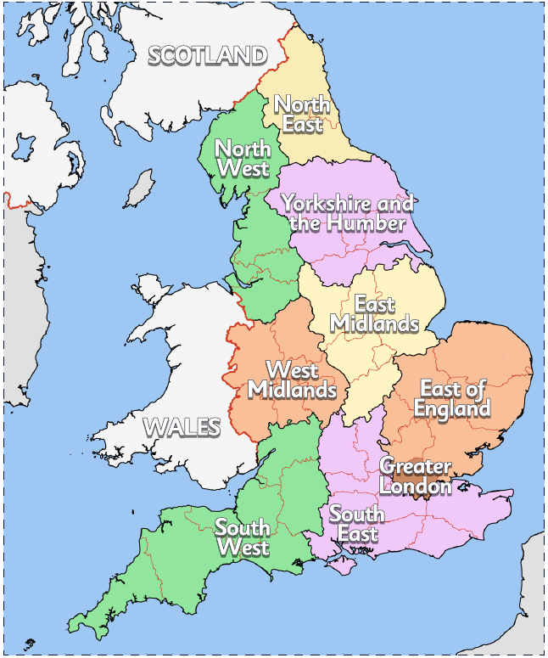

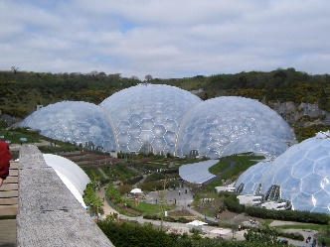
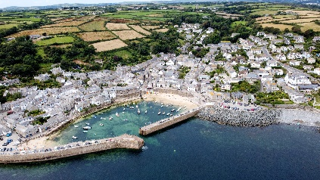

Physical Geography

Physical Geography refers to the features of the Earth, such as oceans, mountains, rivers, coastlines, forests and plant life. Physical features in Cornwall include places such as, Bodmin Moor, St Michaels Mount, Clay Pits – St Austell, Lands End Cliffs, St Ives Bay and Perranporth Beach.
Compass and Compass points
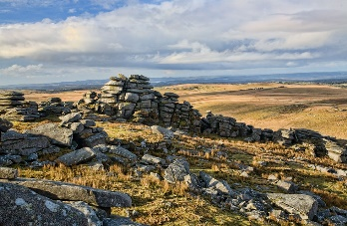
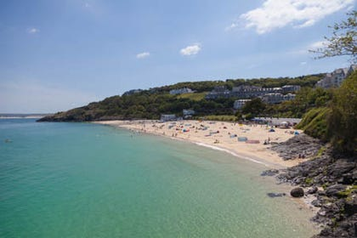
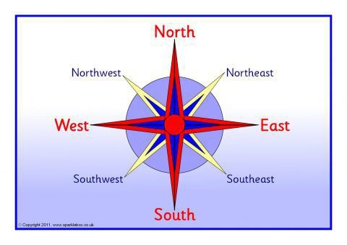
Compass | A tool for finding direction.
Compass Points | The directions on a compass.
Village | A small settlement usually in a rural area.
Town | A type of urban settlement larger than a village.
City | A type of urban settlement larger than a town.
Settlement | Places where people live and work.
Human Geography | Something that is built by humans and would not have existed in nature without humans.
Physical Geography | The physical features of the Earth, such as oceans, mountains, rivers, coastlines, forests and plant life.
Geographical Regions | The areas that the UK is divided into.
Human features | Physical features
The Guild Hall | The Cober River
The Boating Lake | Penrose
St Michael’s Church | Loe Pool Lake
Grylls Monument | Dagibna Woods
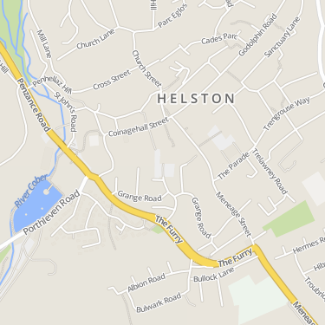
What features in Cornwall support a happy and healthy lifestyle?
Human and physical features of Helston.
Fieldwork
Key Vocabulary

