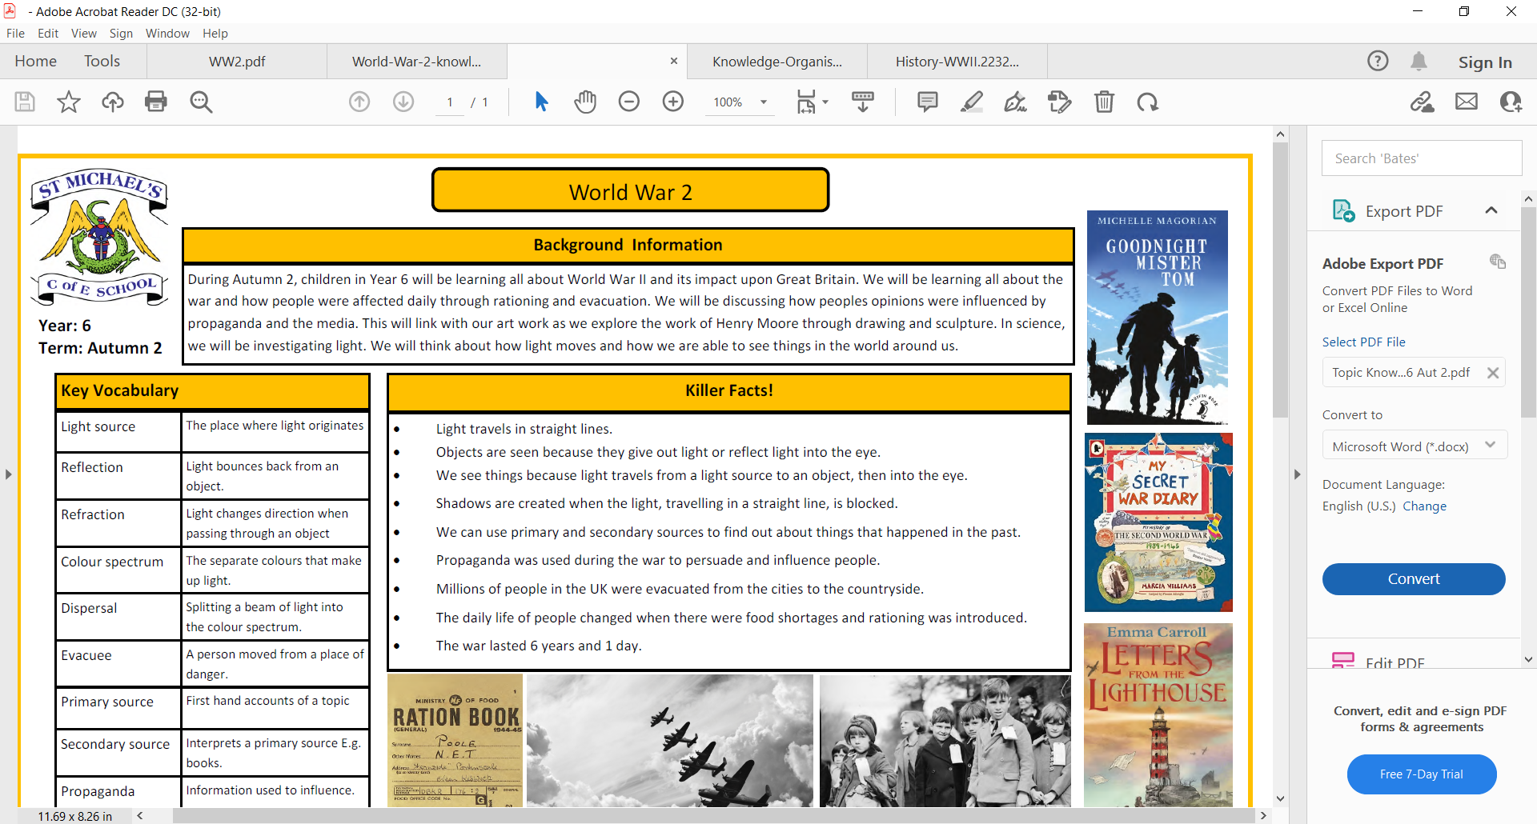

Plants

Water Transportation

Parts of a plant

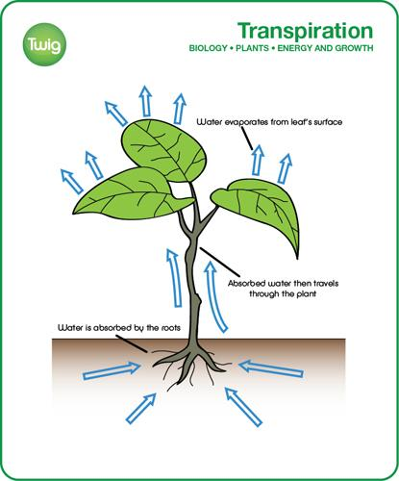

The plant collects water and nutrients from the soil. This is then transported through the stem. Inside the stem are tubes called xylem. The water and nutrients are then transported to the leaves so that the plant can make its own food.

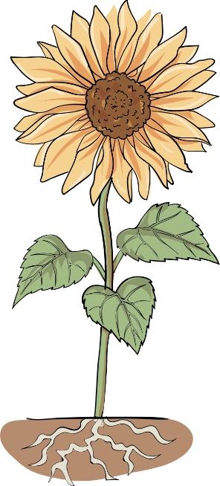

Roots

Flower

Leaves

Stem

Pollination

|  |  |
| --- | --- |
| Flower | The flower is brightly coloured to attract birds and insects. |
| Stem | The stem holds the plant up. |
| Leaves | The leaves catch the sunlight so that the plant can make its own food. |
| Roots | The root takes in the water and nutrients from the soil. |

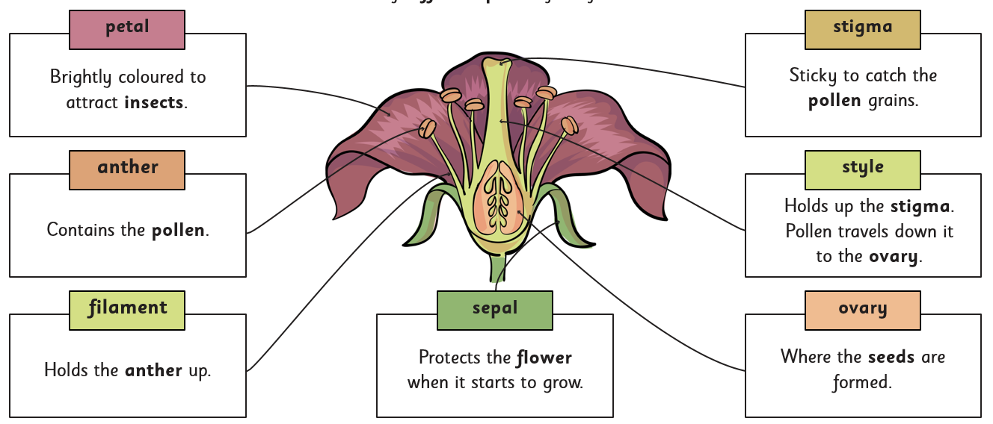

|  |  |
| --- | --- |
| **Roots** | Something that collects water and nutrients from the soil. Helps the plant stay upright. |
| **Stem** | The main body of the plant that holds the leaves and helps to transport the water. |
| **Leaves** | Are attached to the stem and help the plant to make food. |
| **Flower** | The flower is the bloom or blossom of the plant. |
| **Nutrients** | Substances that nourish a plant. |
| **Pollination** | When pollen from the anther is transferred to the stigma. |
| **Function** | A synonym for job, or what it does. |
| **Germination** | When a seed breaks open and sends out a root and a green shoot. |
| **Reproduction** | When a new plant is made. |
| **Transportation** | Moving from one place to another. |
| **Xylem** | Miniscule tubes in the stem, that carry water and nutrients, from the roots, to the rest of the plant. |
| **Dispersal** | When a plants spreads its seeds. |
| **Carbon Dioxide** | Is a gas produced when humans breathe out, that plants take in. |
| **Oxygen** | Is a gas produced by plants and is a very important gas that humans breath in. |

|  |  |
| --- | --- |
|  | Some plants explode, causing the seeds to scatter over a larger area. The poppy is an example of a plant that does this. |
|  | Some plants that grow near water have seeds that will float. The seeds then float until they are washed up on land again. The coconut is an example. |
|  | Some animals eat the fruit of a plant that contains the seeds. When the animals excrete the waste, they also get rid of the seeds, leaving them in a new place to grow. |
|  | Some plants use the wind to disperse their seeds. These seeds are usually light and easy to blow away. |

Images from Grammarsaurus



What do plants need to grow?

Plants need 5 things to grow and stay healthy. These are water, air, light, nutrients and space.

Seed dispersal

Key Vocabulary