Key concepts:
Place
Physical and Human Processes
Environmental Impact and sustainable development
Extreme Earth

Volcanoes
e
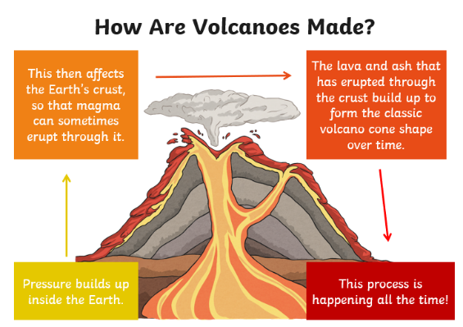
Tectonic plates
Volcanoes are made when pressure builds up inside the earth. At times, this can affect the earth’s crust and magma will erupt through it.

The Earth’s crust is not one solid layer. It is broken up into huge areas called tectonic plates. These float on top of the mantle. The plates can move around and when they collide, volcanoes can erupt, or it can cause an earthquake or tsunami.

Earthquakes

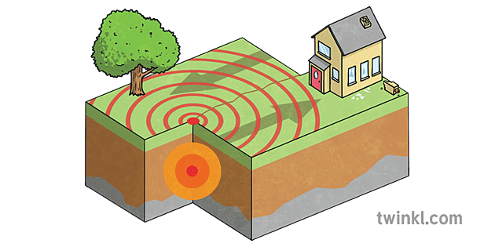
Earthquakes occur when tectonic plates suddenly move. This usually happens on or close to the tectonic plate boundaries. Earthquakes can cause lots of damage to roads and buildings.
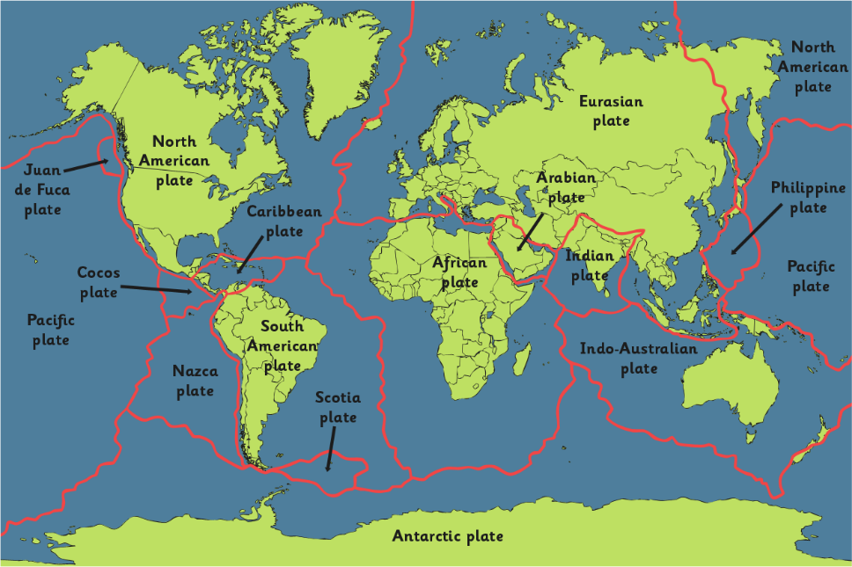

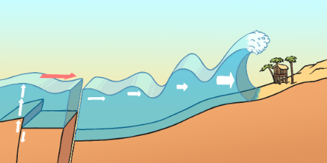
A tsunami is a giant wave. This is caused by an earthquake under the ocean. The earth quake causes a series of waves that get bigger and bigger, then crash onto the land.
Tsunami
Compass | A tool for finding direction.
Compass Points | The directions on a compass.
Volcano | An opening in the Earth’s surface, usually in a mountain, which allows gas, hot magma and ash to escape from beneath the Earth’s crust.
Mountain | An area of land that is much higher than the land surrounding it.
Earthquake | The movement of rocks beneath the Earth surface making the ground shake.
Tsunami | A large wave caused by movement in the Earth’s crust.
Tectonic plates | The earth’s crust is made up of large areas called tectonic plates that join together.
Coast | A strip of land which meets the sea or ocean.
Map | A representation of an area of land and sea.
Atlas | A book of maps and charts.
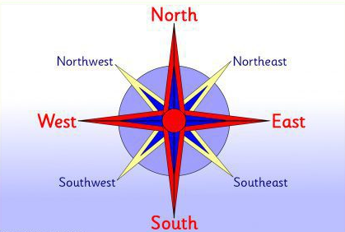
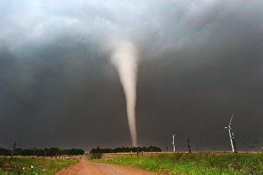
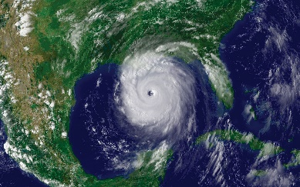
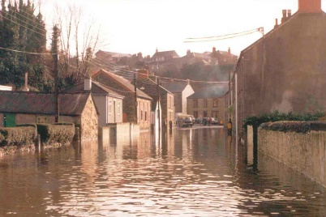
Images from Twinkl
Other types of extreme weather are thunder and lighting, flooding, tornadoes and hurricanes.
Compass and Compass points
Extreme weather
Key Vocabulary
What is life like for those affected by extreme weather and how can we support them?

