Magnets
Types of Magnet
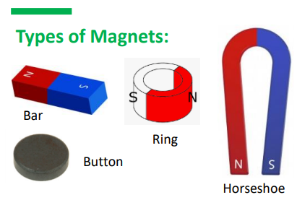
Forces
Magnets can be lots of different shapes, sizes and colours, but they will always have a north and south magnetic pole.
A force is a push or pull that acts upon an object. We can't see forces, but they are an important part of our everyday lives.

We push and pull objects to do many different things. When we push or pull objects, we can move the object, change the object’s shape, or make the object change direction.

Magnets are usually made from iron. They can attract and repel other objects with their magnetic forces. Magnetic forces act at a distance meaning that a magnet does not need to be in contact with another object for the magnetic forces to act.
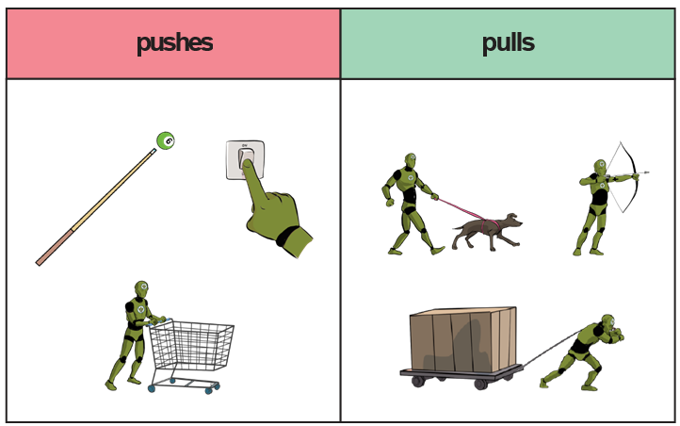
Magnetic Materials

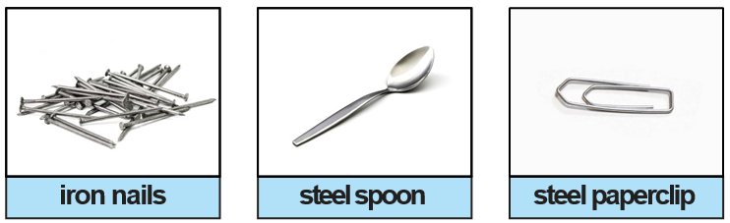

Not all metals are magnetic. Iron and steel are two metals that are.
push | To move something away.
pull | To move something towards.
magnet | Something that has a North and South pole, which attracts and repels magnetic objects.
magnetic | Something that is attracted to a magnet.
magnetic field | The space around a magnet within which the force of magnetism acts.
attract | A pulling force created by a  magnet.
repel | A pushing force created by a  magnet.
contact | When one thing touches another for a force to happen.
non-contact | A force which acts on an object without coming physically in contact with it.
north pole  and  south pole | The North and South poles are opposite  ends of a magnet. The magnetic field flows from North to South.
friction | the force that acts upon one surface when it moves against another.
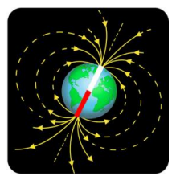
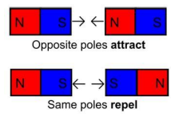
The Earth has a magnetic field, having a North Pole and a South Pole.
Same poles repel.
If you try to put two magnets together with the same poles pointing towards one another, the magnets will push away from each other. We say they repel each other.
Different poles attract.
If you put two magnets together with different poles pointing towards one another, the magnets will pull towards each other. We say they attract each other.
Magnet and their poles
Images from Grammarsaurus
Key Vocabulary

