North America compared to the UK
&
Topography
How are mountains formed?

Topography
How is height shown on a map?
Fold Mountains occur when tectonic plates collide.

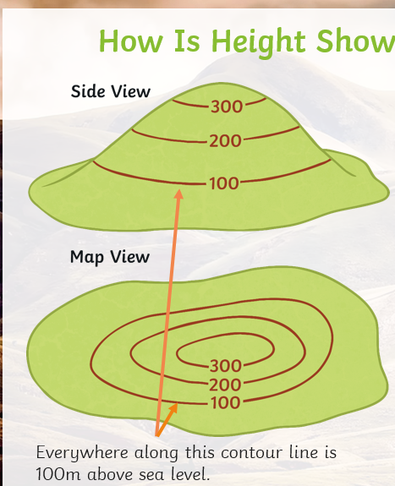
Fault Block Mountains are formed because of rock and magma being pushed up.

Plateau Mountains are formed by materials being taken away through erosion, which has left deep valleys, or gorges nest to high cliffs.
- These lines on a map join land that is of the same height.
- They are usually marked in 5m or 10m intervals.
- The closer the lines are together the steeper the slope will be.

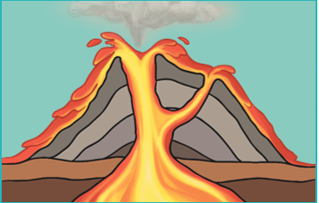
Volcanic Mountains are formed around volcanoes and made up of layers of ash and cooled lava. Do you remember this from year 3 learning?

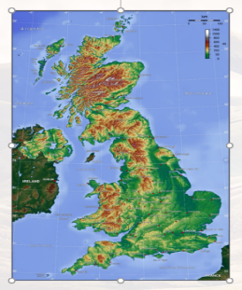
Layer Shading
Layer shading is often used on maps of very large areas like countries. It gives a good overview of the relief of that area.
The highest areas are usually shaded in brown and the flatter areas in shades of green.

Dome Mountains are formed when magma is forced up between the crust and the mantle, but does not flow out.
Key Vocabulary

Physical Geography | - The branch of geography dealing with how human activity affects or is influenced by the earth's surface.
Human Geography | The branch of geography dealing with natural features.
Mountains | Areas of land that are much higher than the land surrounding them.
Hills | A landform that is higher than the surrounding land and has a visible summit; they're like mountains, only shorter.
Topography | Describes the physical features of an area of land.
Topographical features | These features typically include natural formations such as mountains, rivers, lakes, and valleys.
Relief | Relief refers to the way the landscape changes in height. Upland areas are high above sea level. They are often (but not always) mountainous. Lowland areas are not very high above sea level. They are often flat.
Sea level | A term used to describe what the height of the ocean usually is.
Contour lines | Lines that join up areas of equal height on a map.
Size | Approx. 9,984,670 square kilometres
Population | 39,858,480
Average rain fall | 537 mm per year
Coastline | 202,080 km
Terrain | Mostly plains with mountains in west and lowlands in southeast
Capital cities and the physical geographical features of Canada

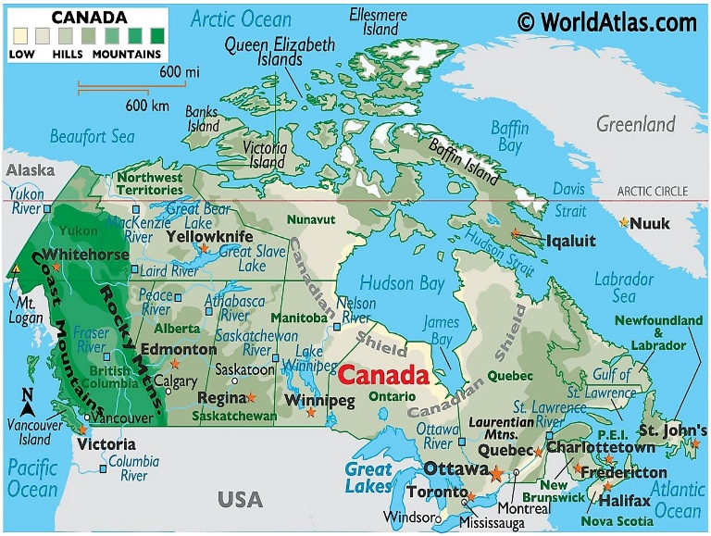
Capital cities and the physical geographical features of the UK

Size | Approx. 243,610 square kilometres
Population | 67.8 million
Average rain fall | 1,220 mm per year
Coastline | 12,429 km
Terrain | Mostly rugged hills and low mountains; level to rolling plains in east and southeast

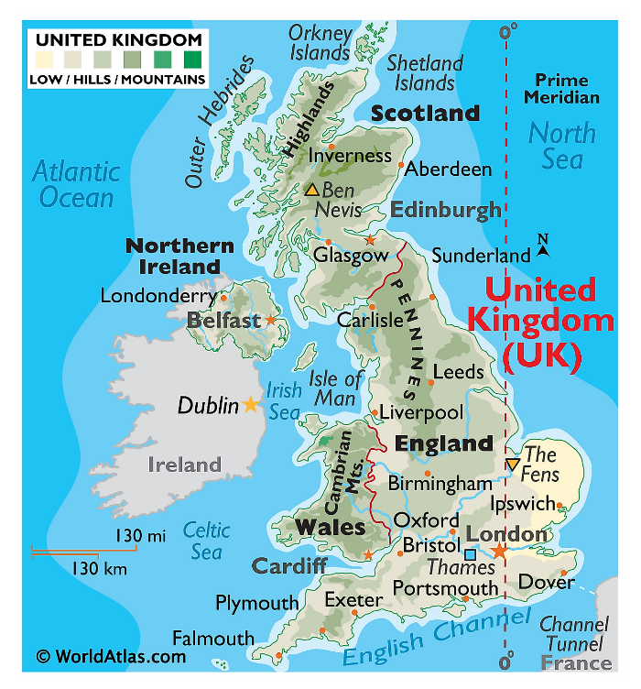

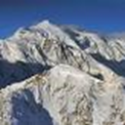
The highest Mountain in Canada is Mount
Logan at 5,959m.
- Mountains are a natural part of the landscape with steep slopes.
- They rise above 300m
- They have a summit of at least 600m
- Some mountains are found in groups called a mountain range but some can stand alone.
- Not all mountains are single summits.

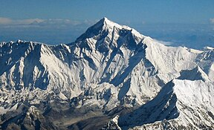
The highest mountain in the world is Mount Everest at 8,848m.

The highest mountain in the UK is Ben Nevis at 1,345m.
- Locate countries in North America and the capital cities, using maps to concentrate on their environmental regions, key physical and human characteristics.
- Name and locate key topographical features of mountains and hills.
- Understand geographical similarities and differences through studying the human and physical geography of a region in the UK compared with a region in N. America with significant differences and similarities.
- Describe and understand key aspects of physical geography including mountains.
- Use maps, atlases, globes and digital/computer mapping (Google Earth) to locate countries and describe features studied

