Light
Reflection
What is light?
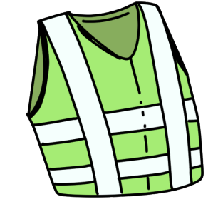
Shiny materials will reflect the light better than matt materials. Reflective clothing can also be worn so that walkers and cyclists can be seen by drivers.
Light is a type of energy. It helps us to see. If there is no light, it is dark. When it is dark, we cannot see.

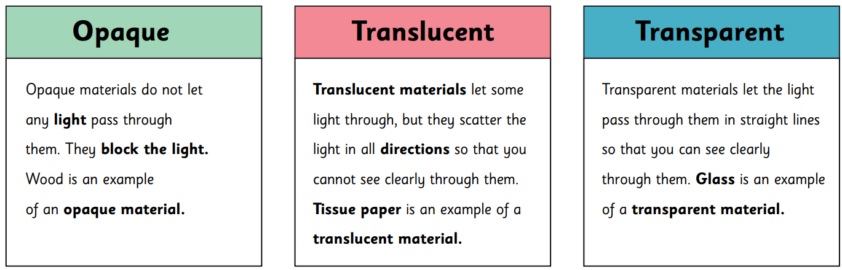
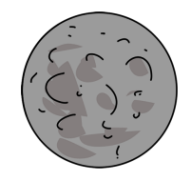
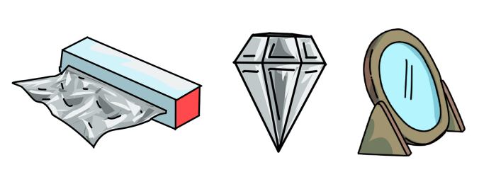

Sunlight
Types of Light Source
The light from the sun can be dangerous. It is capable of damaging our eyes. We must never look directly at the sun. We can protect our eyes by wearing sunglasses and sunhats .
There are many different types of light source. Some are natural and others are artificial.
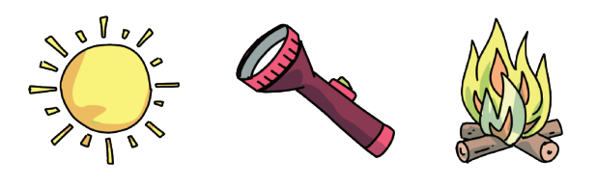
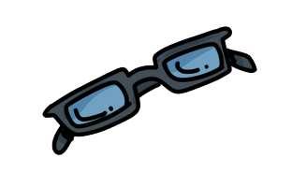
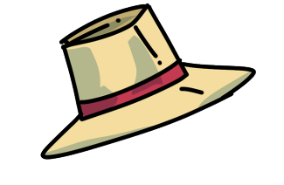
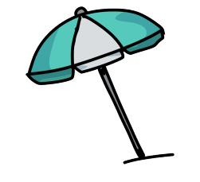
night | The part of the day when it is dark.
day | A period of 24 hours. Some of it is light.
opaque | Something that does not let light through and  makes a shadow.
transparent | Something that does let light through and therefore you can see through it.
light | Something that we need to be able to see.
dark | The absence of light.
shadow | When an opaque object blocks the light.
absence | When something is not there.
reflect | To bounce light back without absorbing it.
reflected | The light that bounces off an object.
reflective surface | A surface that can bounce back light.
light source | Something that produces light.
translucent | Something that lets light through but that you cannot see through.
mirror | A surface which reflects a clear image.
bounce | An object that moves away quickly after hitting a surface.
The existence of nearly all life on earth is fueled by light from the sun.
A shadow is created when an opaque shape blocks the light from getting through. This creates a dark shape or outline on the surface behind the object. This is a shadow.

The size of a shadow can be changed when the position of the following things are moved:
- Light source
- Object
- The surface where the shadow is being made.
Shadows
Images from Grammarsaurus
Key Vocabulary

