Valley of the Kings
Key concepts:
Settlements and Civilisations Progress and Change
Religions and Beliefs
Historical figures
Lifestyles

7500 BC/BCE | 3200 BC/BCE | 2640 BC/BCE | 2555 BC/BCE | 2000 BC/BCE | 1332 BC/BCE | 51 BC/BCE
First settlers arrive in the Nile valley. | Trade increases in the Nile valley. | The first pyramids are built. | The Giza pyramids are built for the kings Khufu, Khafre and Menkaure. | Farming develops around the banks of the river Nile. | Tutankhamun becomes Pharaoh of Egypt. | The reign of Cleopatra begins.
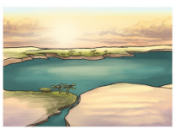 | 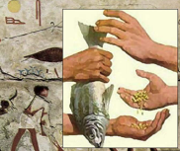 | 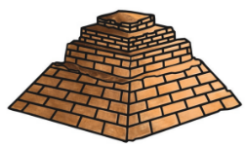 | 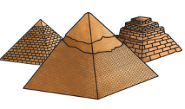 | 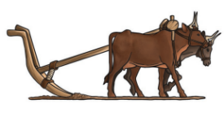 | 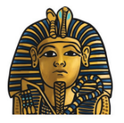 | 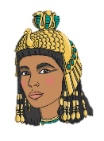

Enquiry question: Why was the Nile so important to Ancient Egypt?
Timeline

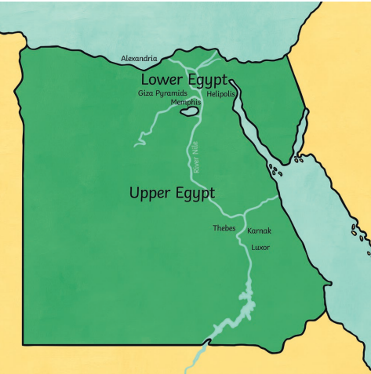
The Importance of the River Nile
Every aspect of life in Egypt depended on the river – the Nile provided food and resources, land for agriculture, a means of travel, and was critical in the transportation of materials for building projects and other large-scale endeavours. It was a critical lifeline, that literally brought life to the desert.

Key People
Kings Khufu, Khafre and Menkaure were Ancient Egyptian Pharaohs, who are famous for building the Great Pyramid at Giza, one of the seven wonders of the world. | 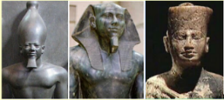
Tutankhamen is famous because his tomb was the only royal burial found intact in modern times. The tomb was important because it let archaeologists record what an Egyptian king's tomb looked like and learn more about ancient Egypt. | 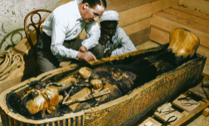
Cleopatra was the last queen of Egypt. Her death brought an end to the Egyptian Empire. | 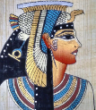
Canopic Jars
How was it possible to build pyramids, without modern technology?
Hapi | Duamutef | Qebehsenuf | Imsety
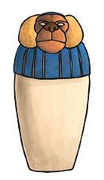 | 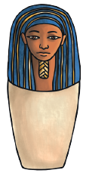 | 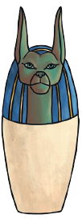 | 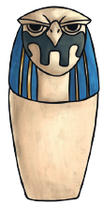
How would it have felt to be a farm worker, compared to a Pharaoh, in Ancient Egypt?

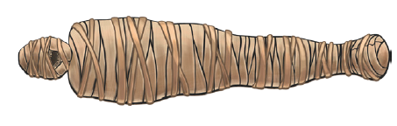
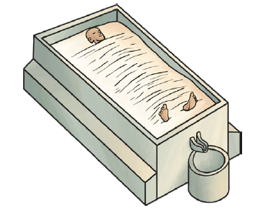
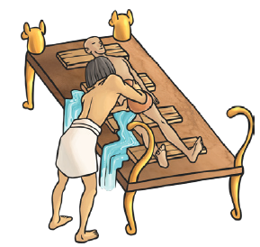

The ancient Egyptians worshipped many gods and goddesses,
who were responsible for different aspects of life and death.
Horus | God of the sky. The ancient Egyptians believed a pharaoh was a god-like living version of Horus.
Thoth | God of wisdom. He is believed to have invented hieroglyphics and kept a record of all knowledge.
Ma’at | Goddess of truth. Pharaohs promised to follow Ma’at and be fair and honest.
Osiris | God of the underworld. He also symbolized death, resurrection, and the cycle of Nile floods, that Egypt relied on for agricultural fertility.
Anubis | God of mummification. He weighed the hearts of the dead against Ma’at’s feather. If the heart was lighter, the person could pass to the afterlife.
Gods and Goddesses of Ancient Egypt
Ancient | Something from a very long time ago.
The Nile | A river that runs through Egypt. It was essential to life in Ancient Egypt.
Civilisation | A human society with well-developed rules and government.
Beliefs | A part of belonging to a religion.
Leisure | Activities you can do in your free time.
Pharaoh | A ruler in Ancient Egypt.
Pyramid | A stone structure, built in the shape of a pyramid, in Egypt.
Mummification | The process of preserving a body after death in preparation for the afterlife.
Canopic Jar | Special jars that held the organs of a mummy including the lungs, intestines, liver and stomach.
Primary Source | First-hand account of an event.
Secondary Source | Interprets a primary source e.g. books
Chronology | A series of events in the order in which they happened.
BC/BCE | BC – before Christ  BCE – before common era
AD/CE | AD – Anno Domini  CE – common era
Key Vocabulary

Images from Twinkl

