Please practise these at home, using the strategies on the back of this sheet. There will be regular assessment points throughout the term and we will assess your knowledge of the weekly focus spellings throughout the week. These focus words are a continuation of the learning that is taking place at school. There is a limited number of words, to enable deeper learning of increasingly complex words.
Spelling Overview Year 3 Autumn 2
Week 1 spelling checkpoint: Friday 10th November 2023 Week 6: no spellings – recap and practise in school
Week 1  10.11.23 | Week 2  17.11.23 | Week 3  24.11.23 | Week 4  01.12.23 | Week 5  08.12.23
Prefixes mis- and re- added to root words | Year 3 statutory words | Words with /i/ spelt ‘y’. | Year 3 statutory words | Words ending in the /g/ sound spelt ‘gue’ and the /k/ sound spelt ‘que’
reappear | early | gym | length | fatigue
rebuild | extreme | myth | natural | tongue
reread | famous | pyramid | often | league
misbehave | February | mystery | particular | unique
mishear | group | cygnet | possible | antique
mistake | heard | Egypt | special | picturesque

NB: there are no rules that support the spellings this half term. These words just need to be learnt and remembered. The strategies below will support this.
Strategies to support learning spellings at home.
Pyramid words | Identifying tricky part of the word | Trace, copy, replicate
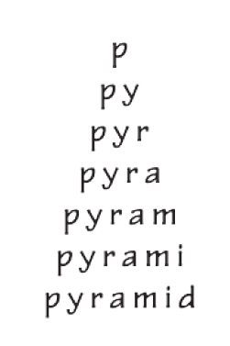 | early  natural  February  group | - Write the word  - Trace over the word and say each letter, as you write it.  - Write the word again while saying each letter, as you write it,  - Check your word
Rainbow Syllables | Drawing around the word to show the shape | Drawing a mnemonic around a word
particular  possible  special  mistake | 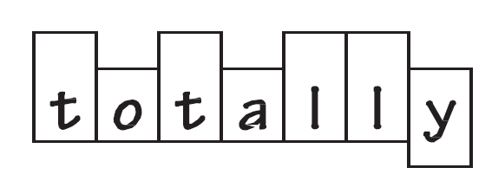 | 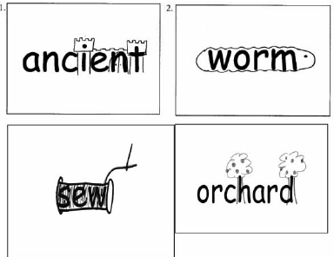
Alternatively, use any other strategy that helps you to remember the spelling.

