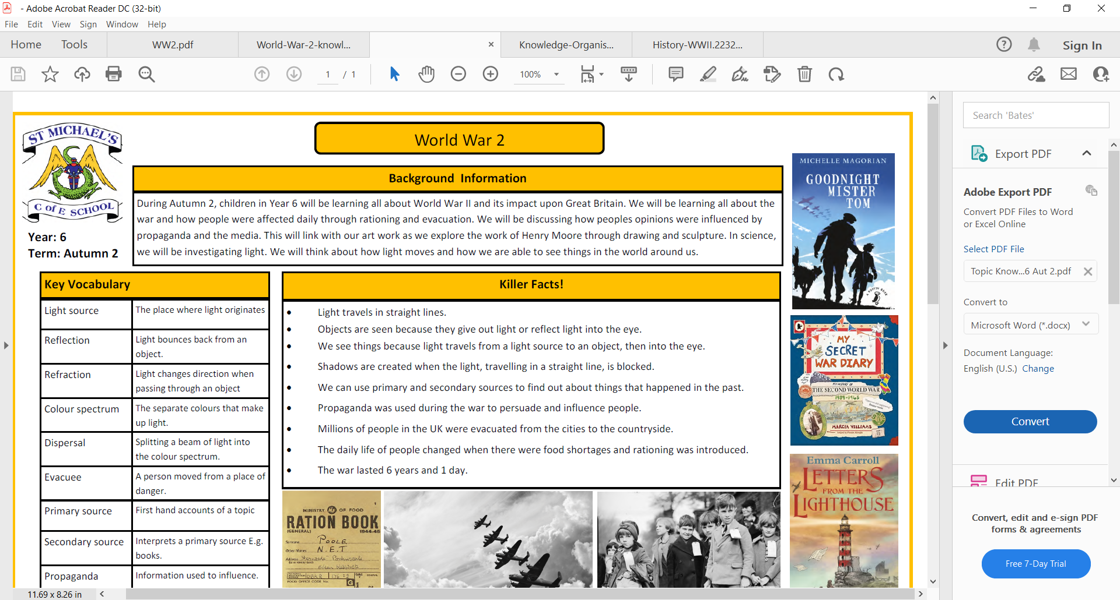

**Countries, Counties and Cities: The UK**

Key concepts:

Space

Place

Physical and Human Processes

|  |  |  |  |
| --- | --- | --- | --- |
| **England** | **Wales** | **Scotland** | **Northern Ireland** |
|  |  |  |  |
| **London** | **Cardiff** | **Edinburgh** | **Belfast** |

**Countries, Flags and Capitals of the United Kingdom**

Land can have many different uses. Land use can be identified by following road signs and symbols, using maps, looking at photographs and speaking to people from the area.

**Land Use**

**4 Types of Settlements**

|  |  |
| --- | --- |
| **Compass** | A tool for finding direction. |
| **Compass Points** | The directions on a compass. |
| **Rural** | An open swath of land that has few homes or other buildings, and not very many people. |
| **Urban** | Areas where many people live and work, resulting in very dense development. The ground is mostly taken up by roads, sidewalks, buildings, and maybe small grassy areas. |
| **Village** | A small settlement usually in a rural area. |
| **Town** | A type of urban settlement larger than a village. |
| **City** | A type of urban settlement larger than a town. |
| **Settlement** | Places where people live and work. |
| **Country** | Land that is controlled by a single government.  There are 4 countries that are part of the United Kingdom (UK): England, Wales, Scotland and Northern Ireland. |
| **County** | A small area of the UK containing lots of towns and villages. |
| **Geographical Regions** | The areas that the UK is divided into. |



Geographical Regions of the UK

Why might some people prefer to live in a rural or urban area?

Key Vocabulary

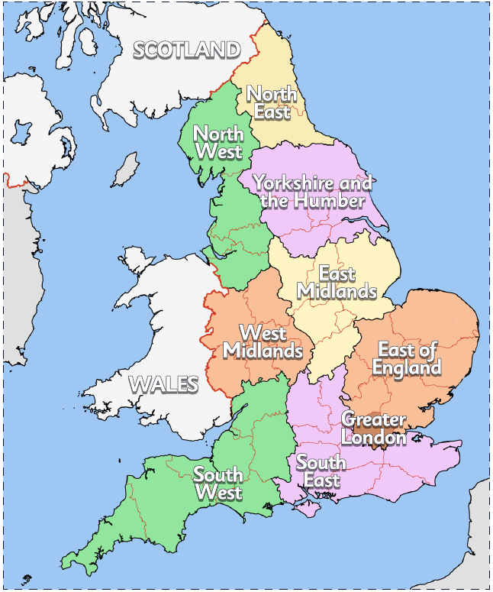

Grid References