Forces - Earth & Space
Out of this world

Phases of the moon
Our Solar System

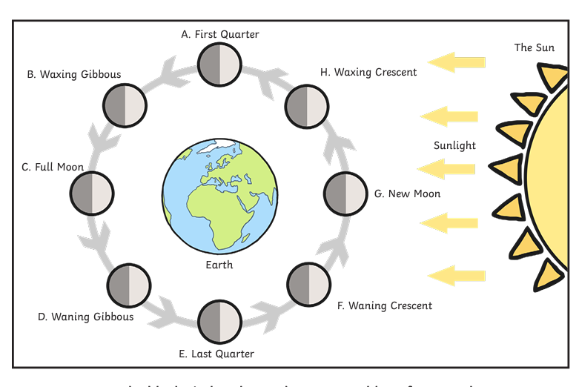
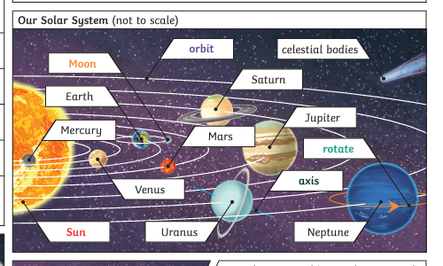

- Stars, planets and moons have such large masses that they attract other things, including each other.
- This force is called gravity.

The Moon’s appearance changes over time when viewed from Earth. Sometimes, the Moon is not easily seen in the sky and at other times it can appear as a thin crescent, a full circle – or somewhere in between.
A Moon phase is the shape of the visible part of the Moon, and this changes gradually over the course of a lunar month.

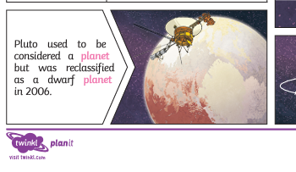

Key Vocabulary
Facts

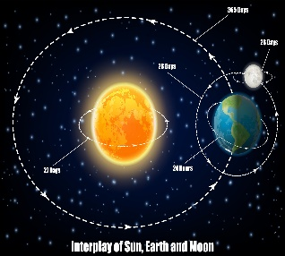
- Our solar system has eight planets: Mercury, Venus, Earth, Mars, Jupiter, Saturn, Uranus, and Neptune.

planet (Mercury, Venus, Earth, Mars, Jupiter, Saturn, Uranus, Neptune) | A celestial body orbiting round a star.
solar system | The collection of eight planets and their moons in orbit round the sun, together with smaller bodies in the form of asteroids, meteoroids, and comets.
spherical body | Something that is spherical; round like a ball.
star | An exploding ball of burning gas held together by gravity.
geocentric model | A geocentric model of the universe is one that places Earth at a fixed position in the middle of the universe, while the rest of the universe orbits and moves around the Earth.
heliocentric model | A heliocentric model is one where the Earth and other planets revolve around the Sun, which is the centre of the solar system.
day | The time of light between one night and the next
night | The time between dusk and dawn when there is no sunlight.
rotation | The movement of an object in a circular motion.
orbit | The path of an object around a particular point in space.
phases of the moon | The different shapes of the Moon that we see at different times of the month.

- Objects with larger masses exert larger gravitational forces.
- Smaller mass objects like planets orbit larger mass objects like stars.

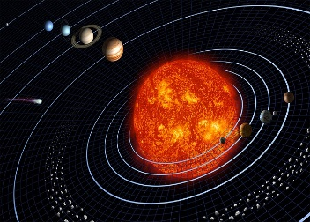
- The sun is the star at the centre of our solar system.
- .

- Objects like planets, moons and stars spin.
- Stars produce vast amounts of heat and light. All other objects are lumps of rock, metal or ice and can be seen because they reflect light.

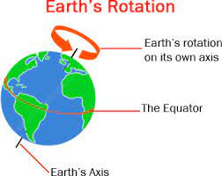
- The Earth rotates once on its axis every 24 hours and the Earth orbits the sun once a year.

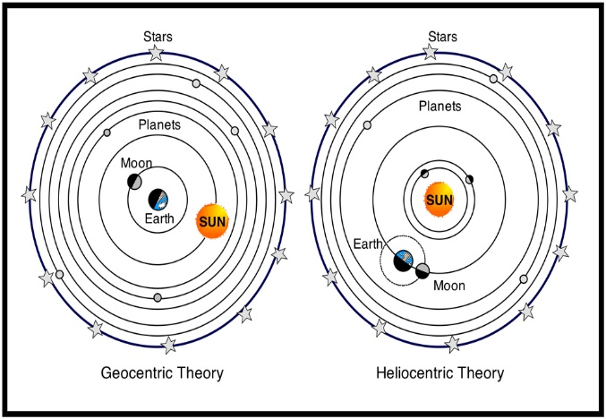
The modern heliocentric model of the solar system has the planets orbiting the sun; the geocentric (older) model had the sun and other planets orbiting the Earth.

Is there life on other planets?

