Settle Down Now
Key concepts:
Settlements and Civilisations
Progress and Change
Lifestyles
300, 000 BC/BCE | 10, 000 BC/BCE | 8,000 BC/BCE | 3,000 BC/BCE | 700 BC/BCE
Palaeolithic Stone Age in Britain | Mesolithic Stone Age in Britain | Neolithic Stone Age in Britain | The Bronze Age in Britain | The Iron Age in Britain
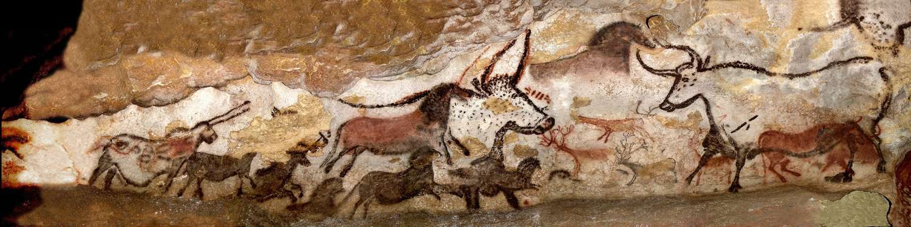  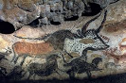 |  |  | 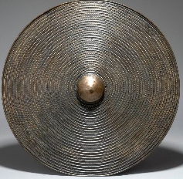 | 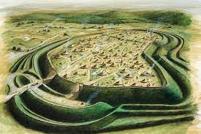

Enquiry question: How did Britain change from the Stone Age to the Iron Age?
Timeline

Early humans may have used art as a way of helping themselves in their struggle for survival. Paintings of animals on cave walls are common. Perhaps this was thought to bring success when hunting or may have acted as a call for help from a spirit world the people believed in.
Progress and Change:
 | Stone Age | Bronze Age | Iron Age
Shelter | 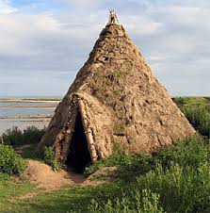 | 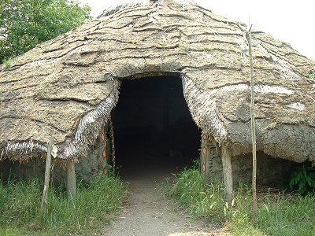 | 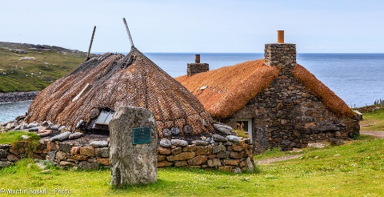
Tools | 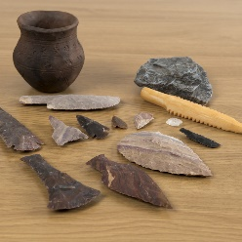 | 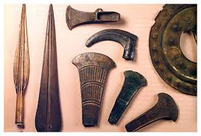 | 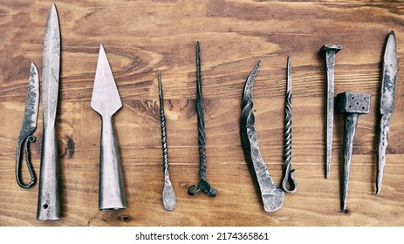

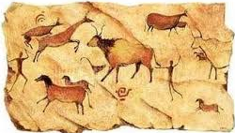

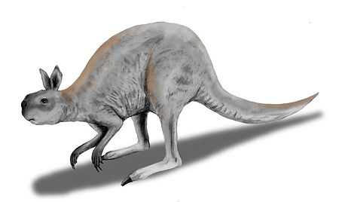
Prehistoric Animals
What struggles did the people of the Stone Age, Bronze Age and Iron Age have to overcome?

How have the actions of early settlers influenced how we live our lives today?

Stone Age | Divided into three periods: Paleolithic, Mesolithic and Neolithic. Marked by the use of tools and a culture of hunting and gathering.
Palaeolithic | Old Stone Age (300,000 BC/BCE to 10, 000 BC/BCE)
Mesolithic | Middle Stone Age (10,000 BC/BCE to 8,000 BC/BCE)
Neolithic | New Stone Age (8,000 BC/BCE to 3,000 BC/BCE)
Bronze Age | Metalworking advances were made, as bronze, a copper and tin alloy, was discovered. Now used for weapons and tools, the harder metal replaced its stone predecessors, and helped spark innovations including the ox-drawn plough and the wheel.
Iron Age | The discovery of ways to heat and forge iron kicked off the Iron Age. At the time, the metal was seen as more precious than gold, and wrought iron was easier to manufacture than bronze.
Roundhouses | Home dwellings consisting of a circular stone wall, with a thatched or turf roof, complete with a fireplace or hearth.
Hill fort | Hill forts were built on hilltops and surrounded by huge banks of soil and ditches. They were protected by wooden walls, which kept enemies out.
Primary Source | Evidence discovered from the time period.
Secondary Source | Interprets a primary source e.g. books
Chronology | A series of events in the order in which they happened.
BC/BCE | BC – before Christ  BCE – before common era
AD/CE | AD – Anno Domini  CE – common era
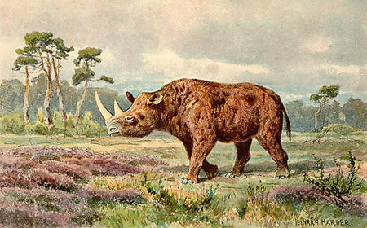

Key Vocabulary

